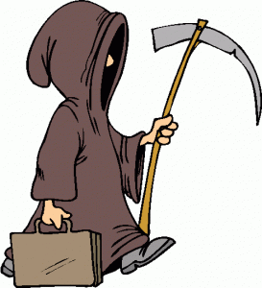

Church + Religion

People had previously seen priests as messengers of God. However, in many cases priests were among the first to die in a community, and priests were more likely to die than the average villager.

How might Black Death have affected people’s relationship with priests, and their willingness to go to church?

Lords + Peasants

Before the Black Death, Peasants had been forced to work for the lord of their village. There were lots of workers so pay was low. Once the Black Death spread there were far fewer workers to plough the fields.

How might Black Death have affected the relationship between the lord and his Peasants?

Landowners

Previously, landowners had been able to charge good rents to freemen to open mills or grow crops on their land. However, many of these people had since died and so much land was going unused.

How might Black Death have affected the money that landowners were able to make. What impact might this have had?

Tradesmen

Richer landowners and lords had begun to employ tradesmen to do tasks like building their new homes or repairing damaged homes. However, after the spread of the Black Death there were many abandoned properties

How might Black Death have affected the ability of tradesmen to make a wage? What impact might this have had?

Peasants

Before 1348, peasants had been forced to live on what little food they could grow that they did have to give to the lord of the manor. They rarely ate meat. However, after the Black Death there was much more food available because so many had died.

How might Black Death have affected the diet of poorer people? What impact might this have had?

Role of Women

Medieval England had been very biased in its treatment of women. They were expected to marry someone chosen by their father, and to obey the orders of their husband. They could not earn money of their own.

How might Black Death have affected women’s lives in medieval England?

